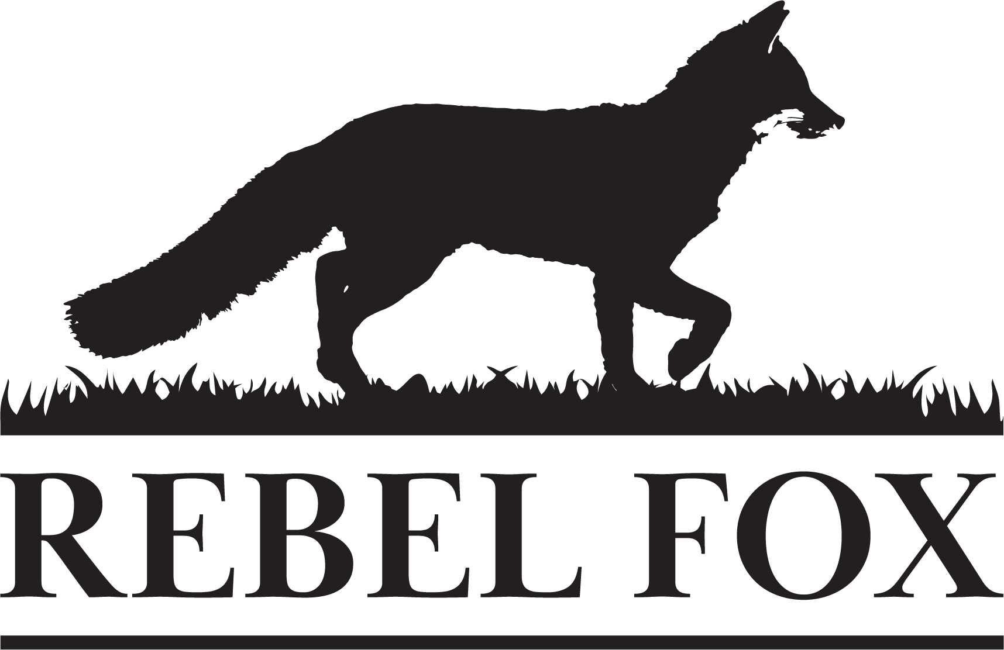

JOB DESCRIPTION

POSITION Creative Director
STATUS Full-Time LOCATION Remote

Creative Director, 10+ years of advertising agency experience
The Job:
Rebel Fox is seeking a Creative Director with a background in art direction and graphic design. This candidate will take on a leadership role helping the agency grow while building a killer portfolio. We’re looking for a curious mind—someone who studies the world and immerses themselves in art, technology, popular culture, and other cool things that fuel their creative fires. Aside from artistic talent, our ideal candidate is resourceful and willing to research, learn, and try new tools, platforms and gadgets. This is a remote work position, but travel will be required at times for client and team meetings.

Job Requirements:
A great eye for design. A way with type. A love of the details.
A meticulous nature, a get-it-right vs. get-it-done mentality.
- Creative responsibilities
- Creative concepting and execution for all channels (digital, video, audio, print, out-of-home, collateral, non-traditional, etc.).
- Guide the visual brand identity for Rebel Fox Farm and help the organization take its own sales materials and web presence to the next level
- Develop spec work for new business pitches
- Leadership responsibilities
- Deliver outstanding client presentations
- Have the ability to scale ideas and deliverables to client budgets at varying levels
- Manage cross-channel deliverables working with other team members
- Mentor and oversee junior creative staff (employees and/or contractors)
- Develop client relationships that make Rebel Fox Farm more indispensable
- Proactively lead the agency’s endeavors to be a creative powerhouse

Experience required:
- Bachelor’s Degree in Graphic Design (accredited by the National Association of Schools of Art and Design [NASAD])
- 10+ years advertising agency experience communicating ideas and selling them to peers and clients
- 10+ years advertising agency art director experience concepting, refining, formatting and delivering finished files appropriate for all media types
- A great portfolio
- Expert skills with InDesign, Photoshop and Illustrator
- Highly organized, detailed file-saving conventions and record-keeping

Benefits:
- Great ideas come from happy people—we place emphasis on work-life balance
- 2 weeks paid vacation
- 5 personal days
- 8 holidays
- Health benefits
- Retirement savings plan

Location:
- This job is remote, enabling the team member to work from home. Travel is required for in-person client meetings and in-person Rebel Fox team meetings.

Status:
- This is a full-time position.

Compensation:
- Salary is commensurate with experience.

